Create 3 networks

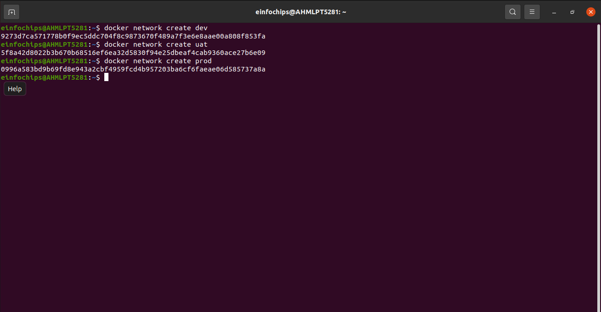
sd

all network has one container ,ignore below image

original command was used later like :
docker network connect nertwork_name servername
after that all ping screenshots are taken

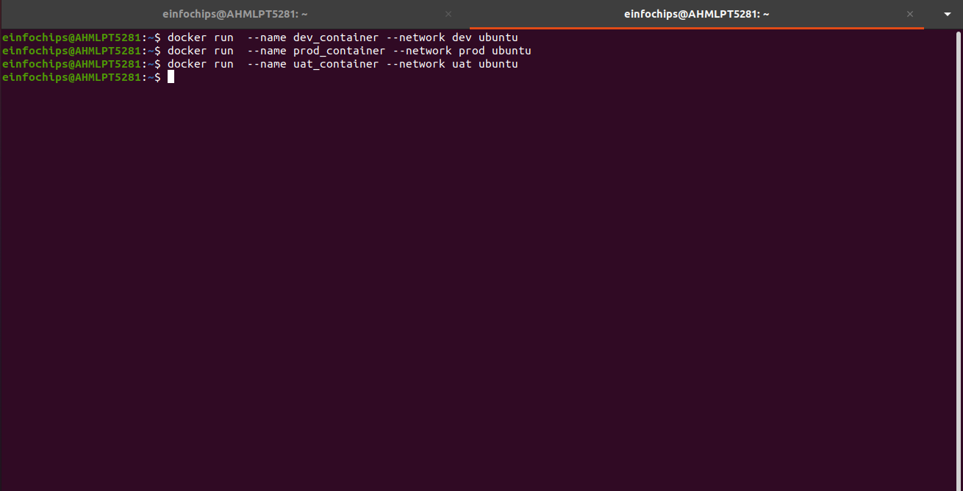
IP OF FIRST CONTAINER DEV

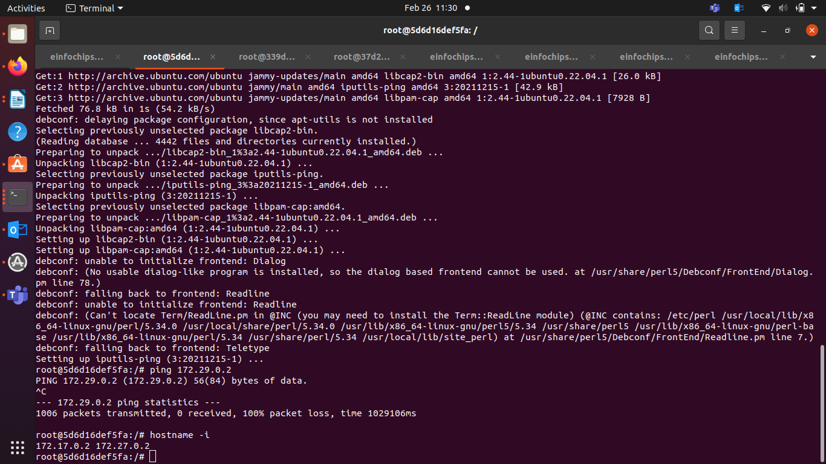
pinging from second

